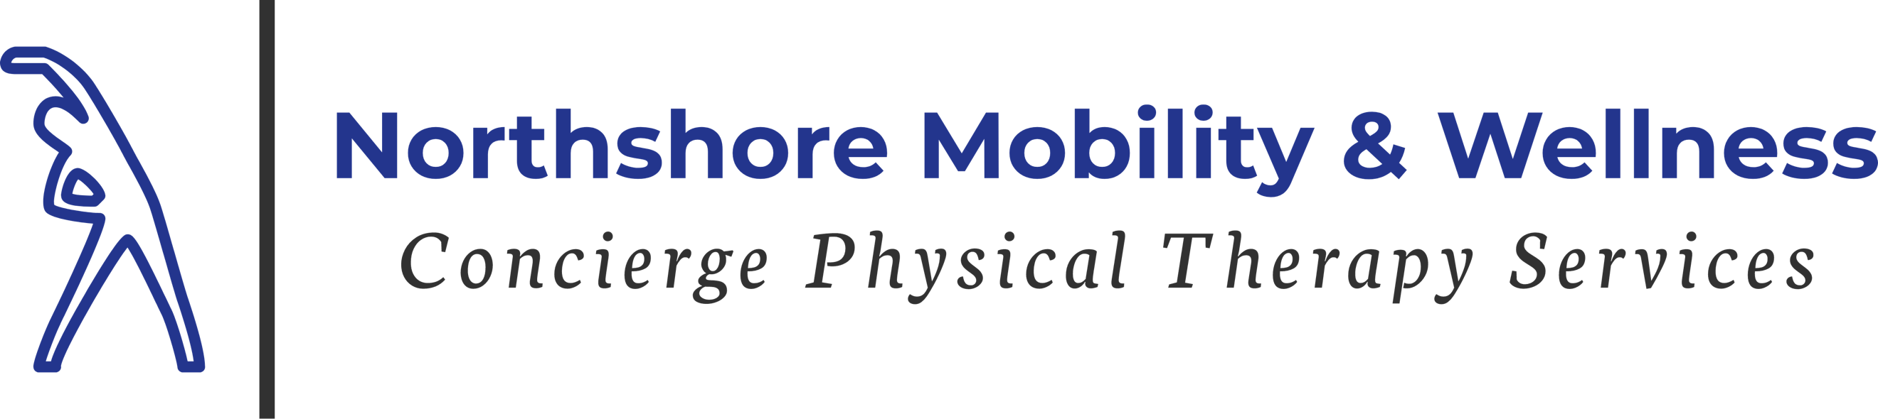
Dry Needling, Cold Laser, & Cupping Informed Consent
The staff at NSMW PT, LLC has received advanced training and certification to perform Dry Needling and cupping therapy.
Dry needling (DN) is a technique that involves the insertion of acupuncture needles into the soft tissues of the musculoskeletal system as a means to promote healing within the body. Treatment techniques are based on concepts of modern medicine and should not be considered acupuncture. Risk of injury is real and potential complications could result from DN if proper precautions are not observed. Pneumothorax could result from insertion of a needle into lung tissue; if DN is practiced properly, threat of pneumothorax is extremely low. Other complications that could result from DN: Bleeding, bruising, infection or nerve injury.
During a DN treatment you may experience temporary: Pain, sweating, nausea, anxiety, dizziness, pain referral or muscle twitch, achiness may linger 1-2 days after treatment. After a DN treatment you may experience temporary: Muscle soreness, muscle tightness, numbness, or joint stiffness. It is recommended that following DN you make an effort to drink water and stay hydrated to reduce the possibility of post treatment soreness.
To avoid any additional risks, and to help your therapist determine if DN is an appropriate intervention for you, please notify your PT if you are pregnant or have any of the following conditions: pacemaker, metal allergies, active skin conditions (psoriasis or eczema), active infection, cancer, osteoporosis, taking blood thinners, any blood infectious diseases, or have any other conditions that you are concerned may have an adverse effect to micro trauma resulting from needle punctures.
DN in the thoracic spine area can be done safely and with great benefit. Special care is taken to identify anatomical landmarks to assure proper needle placement. Due to the fact that the lungs are located in this area of the chest does offer an additional risk. If the lung itself is punctured, you may develop a condition called a pneumothorax (air in the space around the lung). This is a rare but serious problem, and you should seek immediate medical attention if you develop any symptoms of shortness of breath, coughing, or sudden sharp pain with breathing w/in 24 hours of receiving a DN treatment the chest area. Treatment of pneumothorax is very successful for this rare but possible complication.
Cupping Cupping is a technique that utilizes negative pressure to stretch superficial structures in the human body including skin, fascia and muscle tissue. The purpose of this technique is to increase microcirculation of the aforementioned soft tissue structures to enhance the healing process in the human body. Cupping will cause bruising and temporary marks on the skin. More severe complications could result in blistering of the skin.
Cold Laser Therapy (LLT) Low-Level Laser Therapy is an 830 nm laser is optimal for treating chronic pain. An example of how LLLT works involves soft tissue trauma. These types of injuries consist of damage to the deep, sensitive layers of tissue beneath the epidermis, including muscular, neural, lymphatic, and vascular tissue. Low-powered laser beams that produced non-thermal effects on human tissue.
Please consult with your therapist if you have questions regarding DN, Cold Laser, or Cupping that have not been answered after review of this document. I have read this document thoroughly and am aware of the benefits, risks, and conditions where DN, LLT, or Cupping would not be recommended. I have notified my PT of any potential conditions I have that might present a concern for DN, LLT, or Cupping.
Print Name: Date:

Signature of Patient (or Parent/Guardian if minor):

